**React Native Navigation Drawer – Example using React Navigation V5**

Navigation Drawer/Sidebar

This is an example of React Native Navigation Drawer for Android and IOS using React Navigation V5. We will use react-navigation to make a navigation drawer in this example. React Native Navigation Drawer is a very popular component in app development. It provides you to manage the number of app options in a very easy manner. A user can navigate from one screen to another screen very easily by just pulling out the drawer. Here is an example of a navigation drawer.

**Installation of Dependencies**

**npm** **install** @**react**-**navigation**/**drawer** --save

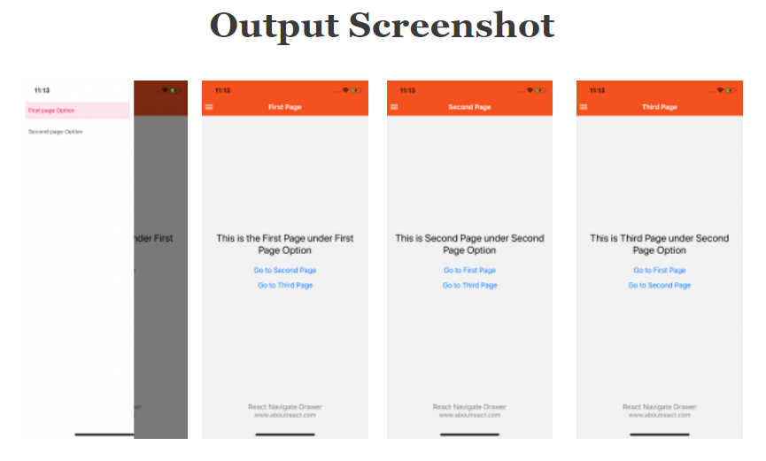

**Code**

### App.js

// React Native Navigation Drawer – Example using Latest Navigation Version //

// https://aboutreact.com/react-native-navigation-drawer //

import 'react-native-gesture-handler';

import * as React from 'react';

import { Button, View, Text, TouchableOpacity, Image } from 'react-native';

import { NavigationContainer } from '@react-navigation/native';

import { createStackNavigator } from '@react-navigation/stack';

import { createDrawerNavigator } from '@react-navigation/drawer';

import FirstPage from './pages/FirstPage';

import SecondPage from './pages/SecondPage';

import ThirdPage from './pages/ThirdPage';

const Stack = createStackNavigator();

const Drawer = createDrawerNavigator();

const NavigationDrawerStructure = (props)=> {

//Structure for the navigatin Drawer

const toggleDrawer = () => {

//Props to open/close the drawer

props.navigationProps.toggleDrawer();

};

return (

<View style={{ flexDirection: 'row' }}>

<TouchableOpacity onPress={()=> toggleDrawer()}>

{/*Donute Button Image */}

<Image

source={{uri: 'https://raw.githubusercontent.com/AboutReact/sampleresource/master/drawerWhite.png'}}

style={{ width: 25, height: 25, marginLeft: 5 }}

/>

</TouchableOpacity>

</View>

);

}

function firstScreenStack({ navigation }) {

return (

<Stack.Navigator initialRouteName="FirstPage">

<Stack.Screen

name="FirstPage"

component={FirstPage}

options={{

title: 'First Page', //Set Header Title

headerLeft: ()=> <NavigationDrawerStructure navigationProps={navigation} />,

headerStyle: {

backgroundColor: '#f4511e', //Set Header color

},

headerTintColor: '#fff', //Set Header text color

headerTitleStyle: {

fontWeight: 'bold', //Set Header text style

},

}}

/>

</Stack.Navigator>

);

}

function secondScreenStack({ navigation }) {

return (

<Stack.Navigator

initialRouteName="SecondPage"

screenOptions={{

headerLeft: ()=> <NavigationDrawerStructure navigationProps={navigation} />,

headerStyle: {

backgroundColor: '#f4511e', //Set Header color

},

headerTintColor: '#fff', //Set Header text color

headerTitleStyle: {

fontWeight: 'bold', //Set Header text style

}

}}>

<Stack.Screen

name="SecondPage"

component={SecondPage}

options={{

title: 'Second Page', //Set Header Title

}}/>

<Stack.Screen

name="ThirdPage"

component={ThirdPage}

options={{

title: 'Third Page', //Set Header Title

}}/>

</Stack.Navigator>

);

}

function App() {

return (

<NavigationContainer>

<Drawer.Navigator

drawerContentOptions={{

activeTintColor: '#e91e63',

itemStyle: { marginVertical: 5 },

}}>

<Drawer.Screen

name="FirstPage"

options={{ drawerLabel: 'First page Option' }}

component={firstScreenStack} />

<Drawer.Screen

name="SecondPage"

options={{ drawerLabel: 'Second page Option' }}

component={secondScreenStack} />

</Drawer.Navigator>

</NavigationContainer>

);

}

export default App;

### Screen1.js

// React Native Navigation Drawer – Example using Latest Navigation Version //

// https://aboutreact.com/react-native-navigation-drawer //

import * as React from 'react';

import { Button, View, Text, SafeAreaView } from 'react-native';

const FirstPage = ({ navigation }) => {

  return (

    <SafeAreaView style={{ flex: 1 }}>

      <View style={{ flex: 1 , padding: 16}}>

        <View

          style={{

            flex: 1,

            alignItems: 'center',

            justifyContent: 'center',

          }}>

          <Text

            style={{

              fontSize: 25,

              textAlign: 'center',

              marginBottom: 16

            }}>

            This is the First Page under First Page Option

          </Text>

          <Button

            onPress={() => navigation.navigate('SecondPage')}

            title="Go to Second Page"

          />

          <Button

            onPress={() => navigation.navigate('ThirdPage')}

            title="Go to Third Page"

          />

        </View>

        <Text style={{ fontSize: 18, textAlign: 'center', color: 'grey' }}>

          React Navigate Drawer

        </Text>

        <Text

          style={{ fontSize: 16, textAlign: 'center', color: 'grey' }}>

          www.aboutreact.com

        </Text>

      </View>

    </SafeAreaView>

  );

}

export default FirstPage;

### Screen2.js

// React Native Navigation Drawer – Example using Latest Navigation Version //

// https://aboutreact.com/react-native-navigation-drawer //

import * as React from 'react';

import { Button, View, Text, SafeAreaView } from 'react-native';

const SecondPage = ({ navigation }) => {

  return (

    <SafeAreaView style={{ flex: 1 }}>

      <View style={{ flex: 1, padding: 16 }}>

        <View

          style={{

            flex: 1,

            alignItems: 'center',

            justifyContent: 'center',

          }}>

          <Text

            style={{

              fontSize: 25,

              textAlign: 'center',

              marginBottom: 16

            }}>

            This is Second Page under Second Page Option

          </Text>

          <Button

            title="Go to First Page"

            onPress={() => navigation.navigate('FirstPage')}

          />

          <Button

            title="Go to Third Page"

            onPress={() => navigation.navigate('ThirdPage')}

          />

        </View>

        <Text style={{ fontSize: 18, textAlign: 'center', color: 'grey' }}>

          React Navigate Drawer

        </Text>

        <Text

          style={{ fontSize: 16, textAlign: 'center', color: 'grey' }}>

          www.aboutreact.com

        </Text>

      </View>

    </SafeAreaView>

  );

}

export default SecondPage;

### Screen3.js

// React Native Navigation Drawer – Example using Latest Navigation Version //

// https://aboutreact.com/react-native-navigation-drawer //

import * as React from 'react';

import { Button, View, Text, SafeAreaView } from 'react-native';

const ThirdPage = ({ route, navigation }) => {

  return (

    <SafeAreaView style={{ flex: 1 }}>

      <View style={{ flex: 1, padding: 16 }}>

        <View

          style={{

            flex: 1,

            alignItems: 'center',

            justifyContent: 'center',

          }}>

          <Text

            style={{

              fontSize: 25,

              textAlign: 'center',

              marginBottom: 16

            }}>

            This is Third Page under Second Page Option

          </Text>

          <Button

            onPress={() => navigation.navigate('FirstPage')}

            title="Go to First Page"

          />

          <Button

            onPress={() => navigation.navigate('SecondPage')}

            title="Go to Second Page"

          />

        </View>

        <Text style={{ fontSize: 18, textAlign: 'center', color: 'grey' }}>

          React Navigate Drawer

        </Text>

        <Text

          style={{ fontSize: 16, textAlign: 'center', color: 'grey' }}>

          www.aboutreact.com

        </Text>

      </View>

    </SafeAreaView>

  );

}

export default ThirdPage;